Notes from The Square Office

From: Mike Greiling, President

Thanks for everyone’s patience regarding the Verizon work going on throughout the neighborhood. I know some have been impacted more than others, but to my knowledge their concerns have been taken care of.
I am looking forward to the installation of the second bench in Stone Park. The city has put the acquisition of the bench on their "to do" list. Our goal to install more trees around the outer perimeter of the Wall is still in process. Chris Jones is getting final approval from the city so we can move forward.
Any neighbors interested in helping to revise the C.C. & R's would be welcome to the 1st meeting on Tuesday, August 19th, 7:00 p.m. at my house, 22162 N.E. Park Lane. Please call ahead and I'll have a cold refreshment for you!
I'm continually thankful every time I come through our neighborhood and see the well-maintained homes lining the streets. A great big thanks has to go out to our volunteer A.R.B. that tries to get 100% compliance from every homeowner and occupant in our Association. It's a thankless job and we are blessed to have folks like Betty Storms, who walks the walk and talks the talk!!

First Annual Village Garage Sale

We had excellent participation by the residents at our First Annual Village Garage Sale. There were 27 homes participating, the weather was perfect and we had a steady stream of shoppers. We would like to extend a very special “Thank You” to Dana Larson for his hard work in preparing all the permanent signs! We look forward to being able to use them in the years to come.
We have had very positive feedback so far and would appreciate your input, both positive and negative. So that we can better plan for next year, please complete the attached postage paid postcard and return at your earliest convenience. Also, if you get a chance, there is a Poll on the website and we would welcome your participation.
We are looking at July 11, 2009, for our next village garage sale and will be providing updates in upcoming newsletters. If you would like to volunteer next year, we would appreciate your assistance. ☺

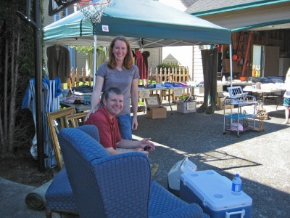

From: The Garage Sale Committee,
(Karin Larson, Melissa Gill, Jean Stadamire and Pat Alfonso)

Next Board Meeting

Tuesday, September 9th at 6:30pm

Location: City Hall

Counting our Pennies
as of 7/31/08

Checking Balance: $13,993.38
Wall Reserve: $35,607.79
Total Assets: $52,072.01

Recent Deposits (June/July): $0.00
Recent Expenditures (June/July): $3,496.28

ARB Report

Our thanks to ALL RESIDENTS for working with the ARB in keeping our neighborhood looking great! We would like to give special recognition to the following homeowners:

Rod & Nancy Painter: 1063 NE Multnomah
Beverly Walthall: 724 NE Pacific Drive

We look forward to recognizing more homeowners in upcoming editions of The Village Sentinel.

Board Members

President: Michael Greiling, 503-667-4097
22162 NE Park Lane
Secretary: Denise Lange
Denise.lange@acs-inc.com
Treasurer: Mick Harris, 503-661-7100
pdxmick@comcast.net
Wall Team: Chris Jones, 503-473-2929
937 NE Pacific Drive
At-Large: Leslie Voge-Hays
red-rose@verizon.net
Patricia Alfonso, 503-661-5389
palfons25@earthlink.net
ARB: Betty Storms, 503-666-1244

Website Update
http://villagefare.com

Minutes from the Annual HOA Meeting and April Board Meeting have been posted on the website along with current copies of the Village Sentinel. These documents will be updated as they become available.
Having problems logging on to the website? Please contact Pat Alfonso at 503-661-5389 or palfons25@earthlink.net.

